Virtual Sessions began on September 13th entitled Sustainable Development Goals of the UN and the Goals of the Encyclical – Laudato Si’. Where Do They Meet? What Can They Teach Us?
Offered twice weekly on Monday and Thursday from 7:30 – 9:00 p.m. 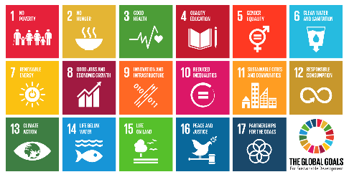
We will explore the Sustainable Development Goals of the United Nations and their call to us. This call is similarly reflected in Laudato Si’ the Papal Encyclical of 2015. It is an opportunity to familiarize ourselves anew with both documents in a relaxed way and to learn together how we as “Ethical Earthlings” can help improve the world we live in for all creatures.
Now that we are permitted to interact indoors, Sister Lois is interested in offering the same course at Nano Nagle Birthplace if people express an interest.

